|  |  |  |  |  |  |
| --- | --- | --- | --- | --- | --- |
| Description | Current | Change | Recommended | Allocation | ICR |
| BT Panorama Super | | | | | |
| Investment number one | $0 | $33,000 | $33,000 | 33.00% | 1.50% |
| Investment number three | $0 | $7,000 | $7,000 | 7.00% | 4.50% |
| Investment number four | $0 | $60,000 | $60,000 | 60.00% | 0.00% |
| BT Panorama Super | $0 | $100,000 | $100,000 |  |  |
| Total | $0 | $100,000 | $100,000 |  |  |

|  |  |  |  |  |  |
| --- | --- | --- | --- | --- | --- |
| Description | Current | Change | Recommended | Allocation | ICR |
| BT Wrap | | | | | |
| Investment number one | $101,000 | -$68,000 | $33,000 | 33.00% | 1.50% |
| Investment number three | $0 | $7,000 | $7,000 | 7.00% | 4.50% |
| Investment number four | $333 | $59,667 | $60,000 | 60.00% | 0.00% |
| Investment number two | $20,000 | -$20,000 | $0 | 0.00% | 0.00% |
| BT Wrap | $121,333 | -$21,333 | $100,000 |  |  |
| MyNorth Super | | | | | |
| Investment number one | $0 | $25,000 | $25,000 | 38.46% | 1.50% |
| Investment number one | $0 | $10,000 | $10,000 | 15.38% | 1.50% |
| Investment number two | $0 | $30,000 | $30,000 | 46.15% | 0.00% |
| MyNorth Super | $0 | $65,000 | $65,000 |  |  |
| Total | $121,333 | $43,667 | $165,000 |  |  |

|  |  |  |  |
| --- | --- | --- | --- |
| Status | Current | Recommended | Alternative |
| Description | BT Wrap | BT Panorama Super | BT Panorama Super |
| Balance | $121,333 | $100,000 | $47,777 |
| One-off Fees Subheader |  |  |  |
| Ongoing Fees Subheader | | | |
| - Sliding Admin Fee | $0.00 (0.00%) | $0.00 (0.00%) | $71.67 (0.15%) |
| - Admin Fee (Flat) | $54.00 | $480.00 | $480.00 |
| - Admin Fee (Floating) | $606.66 (0.50%) | $500.00 (0.50%) | $0.00 (0.00%) |
| Subtotal | $660.66 | $980.00 | $71.67 |
| Adviser Fee (Flat) | $0.00 | None | None |
| Total | $660.66 (0.54%) | $980.00 (0.98%) | $71.67 (0.15%) |
| Comparative Total | $660.66 | $980.00 | $71.67 |

|  |  |  |  |
| --- | --- | --- | --- |
| Status | Recommended | Recommended | Alternative |
| Description | BT Wrap | MyNorth Super | BT Wrap |
| Balance | $100,000 | $65,000 | $78,000 |
| One-off Fees Subheader |  |  |  |
| Buy/Sell Fees | $120.00 (0.12%) | $0.00 (0.00%) | $0.00 (0.00%) |
| One-off Subtotal | $120.00 | $0.00 | $0.00 |
| Ongoing Fees Subheader | | | |
| - Admin Fee (Flat) | $0.00 | $500.00 | $0.00 |
| - Admin Fee (Floating) | $500.00 (0.50%) | $0.00 (0.00%) | $390.00 (0.50%) |
| Subtotal | $500.00 | $500.00 | $390.00 |
| Adviser Fee (Flat) | None | None | None |
| Total | $500.00 (0.50%) | $500.00 (0.77%) | $390.00 (0.50%) |
| Comparative Total | $0.00 | | $1,000.00 |

|  |  |  |  |
| --- | --- | --- | --- |
| - Consol Balance | $265,000 | $265,000 | $265,000 |
| Adviser Fee (Flat) | $0.00 | None | None |

|  |  |  |  |
| --- | --- | --- | --- |
| - Consol Balance | $265,000 | $265,000 | $265,000 |
| Adviser Fee (Flat) | None | None | None |

|  |  |  |  |
| --- | --- | --- | --- |
| Status | Current | Risk Profile | Variance |
| Defensive | | | |
| Casholaaaa | 3.30% | 0.00% | 3.30% |
| Fixed Int | 0.27% | 49.00% | -48.73% |
| Subtotal | 3.57% | 49.00% | -45.43% |
| Growth Subheader | | | |
| Australian Equities | 54.81% | 51.00% | 3.81% |
| Int Eqs | 41.62% | 1.00% | 40.62% |
| Growth Subtotal | 96.43% | 52.00% | 44.43% |
| Alternative Subheader | | | |
| Alternative Subtotal | 0% | 0% | 0% |
| Total | 100.00% | 100.00% | 100.00% |

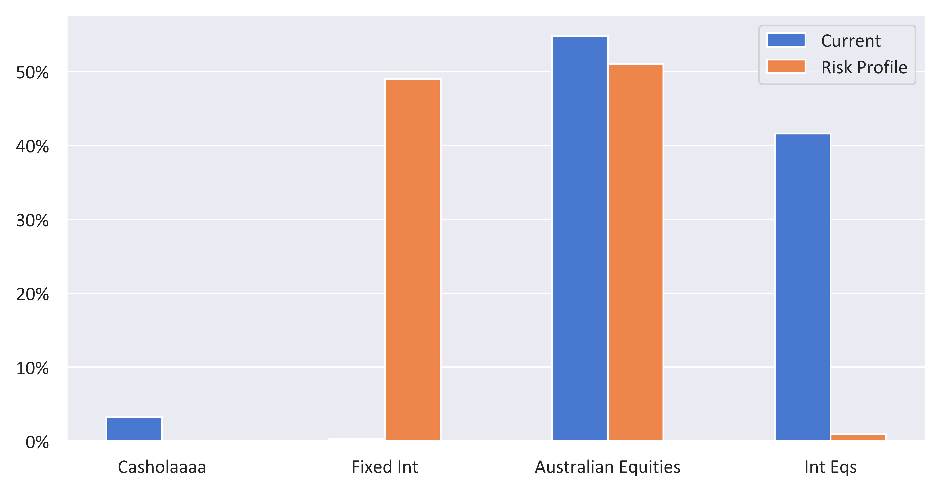

|  |  |  |  |
| --- | --- | --- | --- |
| Status | Recommended | Risk Profile | Variance |
| Defensive | | | |
| Casholaaaa | 7.55% | 0.00% | 7.55% |
| Fixed Int | 44.83% | 49.00% | -4.17% |
| Subtotal | 52.38% | 49.00% | 3.38% |
| Growth Subheader | | | |
| Australian Equities | 28.11% | 51.00% | -22.89% |
| Int Eqs | 19.51% | 1.00% | 18.51% |
| Growth Subtotal | 47.62% | 52.00% | -4.38% |
| Alternative Subheader | | | |
| Alternative Subtotal | 0% | 0% | 0% |
| Total | 100.00% | 100.00% | 100.00% |

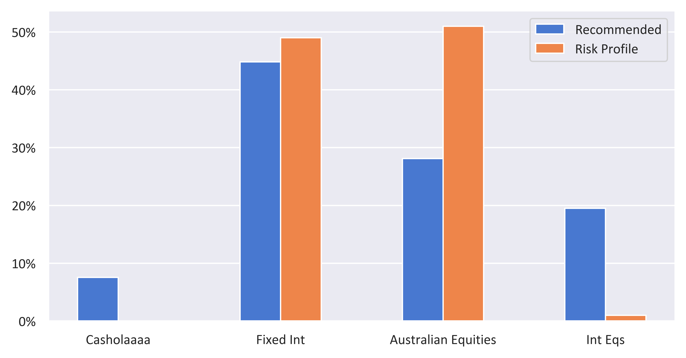

|  |  |  |  |  |
| --- | --- | --- | --- | --- |
| Status | Current | Risk Profile | Recommended | Variance |
| Defensive | | | | |
| Casholaaaa | 3.30% | 0.00% | 7.55% | 7.55% |
| Fixed Int | 0.27% | 49.00% | 44.83% | -4.17% |
| Subtotal | 3.57% | 49.00% | 52.38% | 3.38% |
| Growth Subheader | | | | |
| Australian Equities | 54.81% | 51.00% | 28.11% | -22.89% |
| Int Eqs | 41.62% | 1.00% | 19.51% | 18.51% |
| Growth Subtotal | 96.43% | 52.00% | 47.62% | -4.38% |
| Alternative Subheader | | | | |
| Alternative Subtotal | 0% | 0% | 0% | 0% |
| Total | 100.00% | 100.00% | 100.00% | 0.00% |

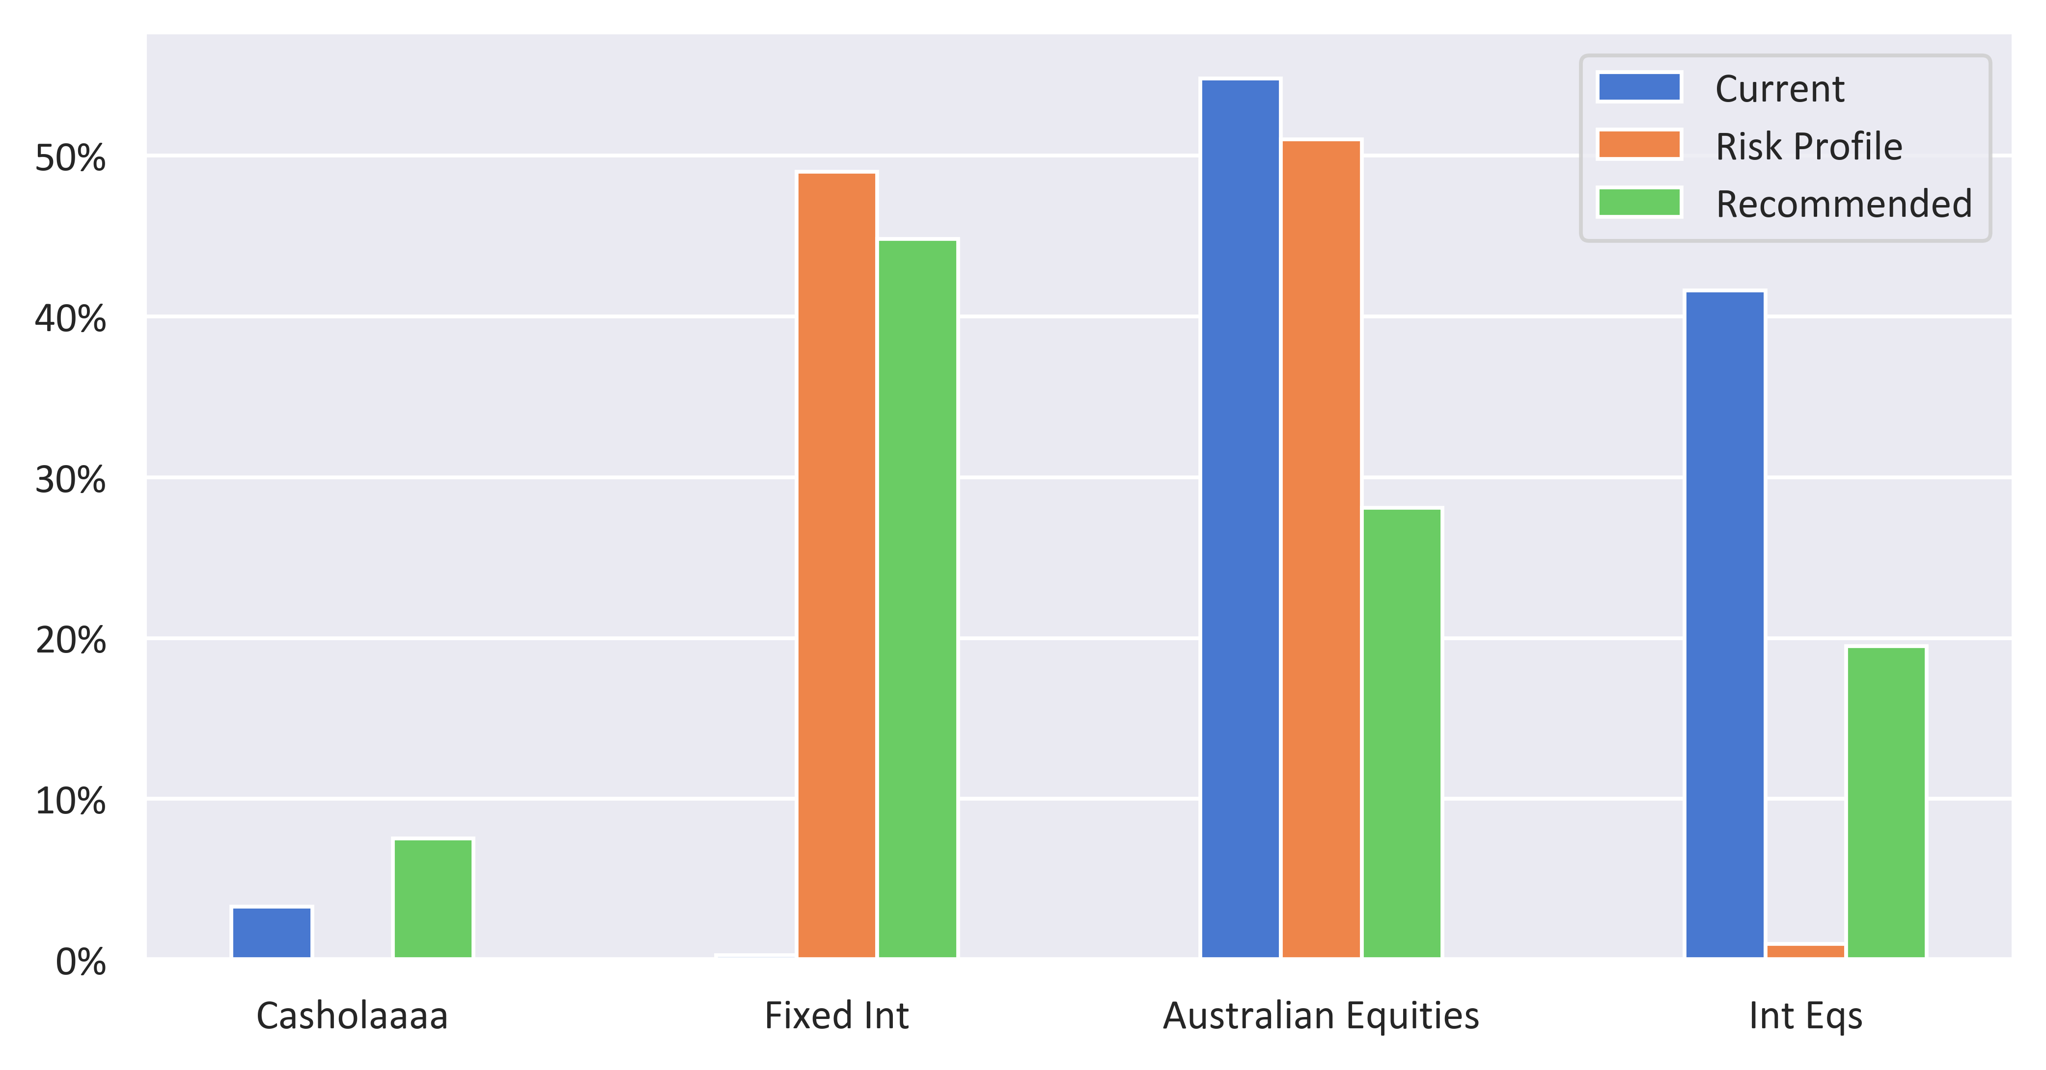

|  |  |  |  |
| --- | --- | --- | --- |
| Status | Current | Recommended | Variance |
| Defensive | | | |
| Casholaaaa | 3.30% | 7.55% | 4.25% |
| Fixed Int | 0.27% | 44.83% | 44.56% |
| Subtotal | 3.57% | 52.38% | 48.81% |
| Growth Subheader | | | |
| Australian Equities | 54.81% | 28.11% | -26.69% |
| Int Eqs | 41.62% | 19.51% | -22.11% |
| Growth Subtotal | 96.43% | 47.62% | -48.81% |
| Alternative Subheader | | | |
| Alternative Subtotal | 0% | 0% | 0% |
| Total | 100.00% | 100.00% | 100.00% |

